# How to write a business letter research

Format Types

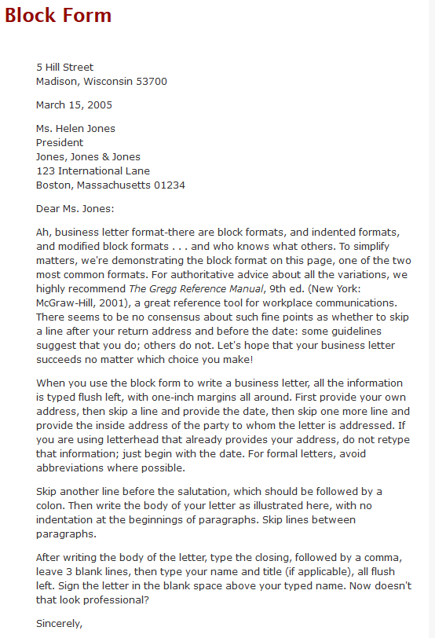

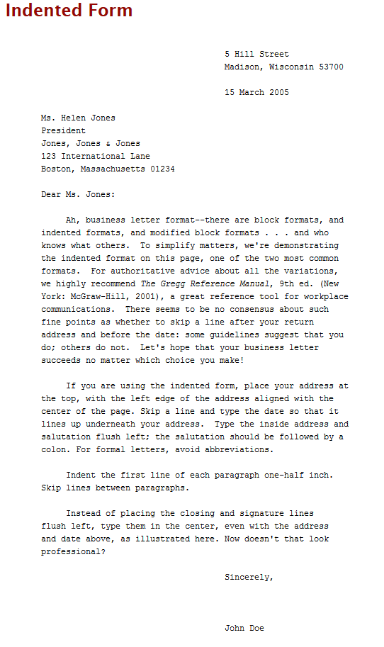

For this business letter the block form style will be used as it provides are cleaner look and is easier to read when compared to the indented format.

Common Abbreviations:

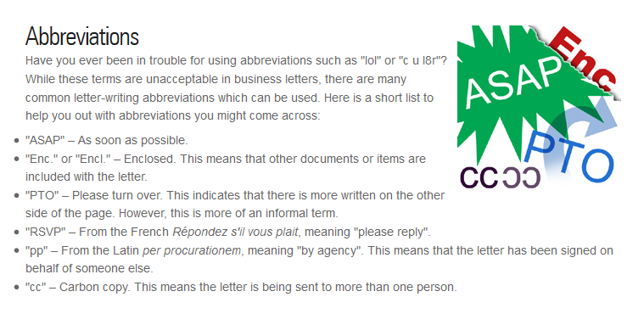

These abbreviations will be useful when the business letter is created.

Types of business letters

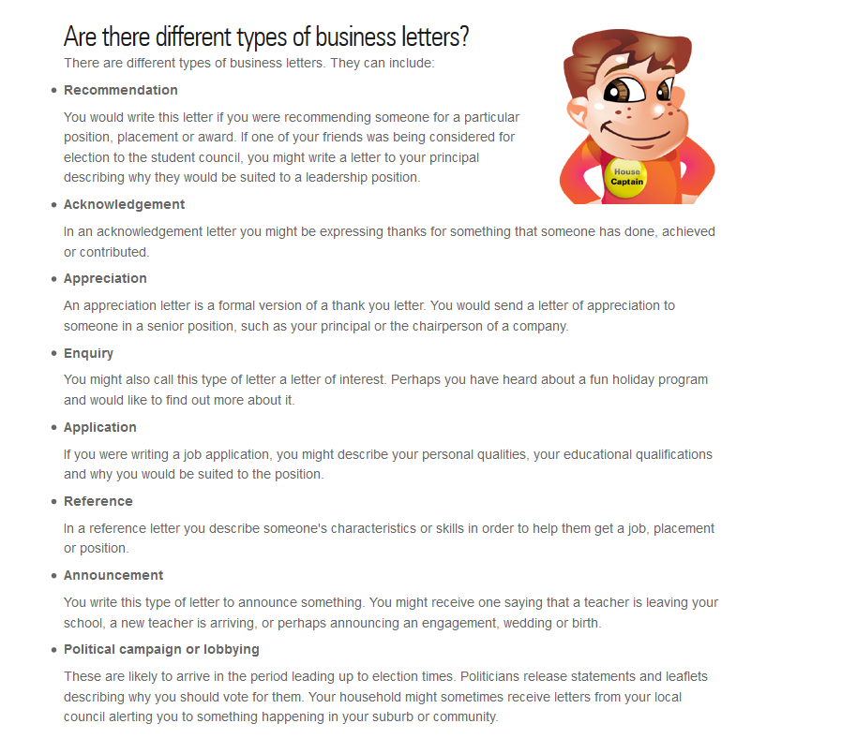

This business letter will most likely be an Acknowledgement business letter as it is a letter that is being written in regards to what the developer team has done.

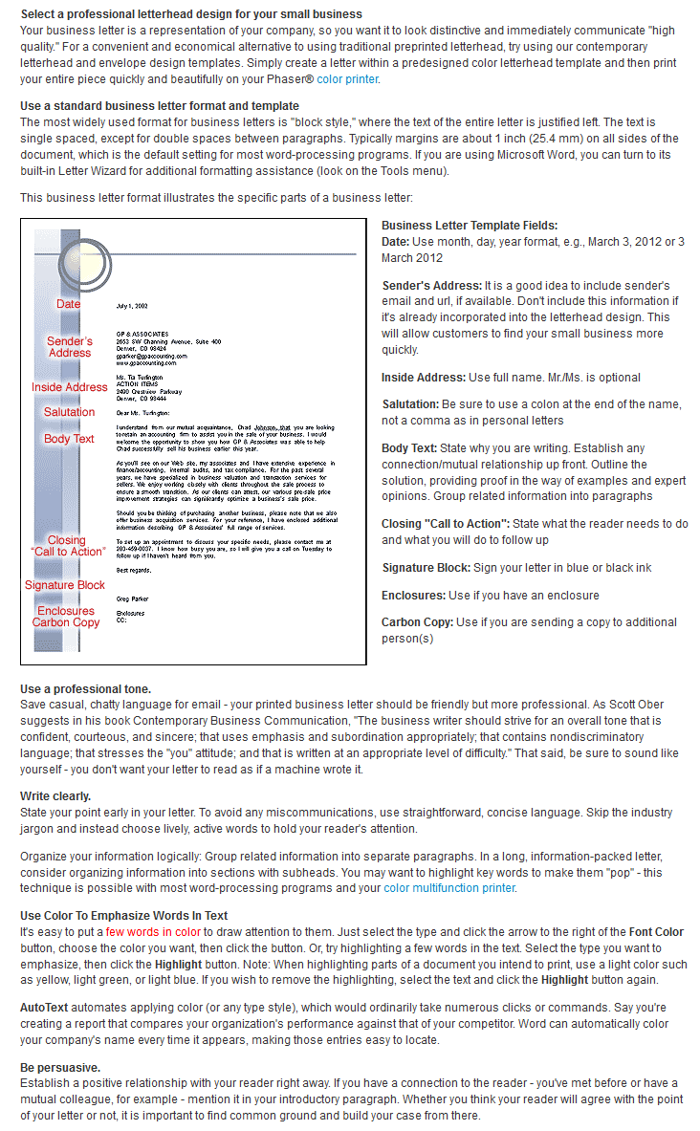

This page details various tips and how to details on how to write an effective business letter. It notes the specific format to use including the fields (date, sender address, inside address, etc). It gives details on how to specifically do these correctly, which will be helpful when it comes to writing the business letter. It also notes to use a professional tone and to write clearly, which will be noted for the business letter.

# Bibliography

Australia Post, n.d. *Writing a business letter.* [Online]   
Available at: http://auspost.com.au/education/letterwriting/students/business-letters.html  
[Accessed 1 September 2016].

The Writing Center, 2014. *Use the menu below to view examples of business letter format..* [Online]   
Available at: http://writing.wisc.edu/Handbook/BusinessLetter.html  
[Accessed 1 Setember 2016].

Xerox, n.d. *Writing An Effective Business Letter.* [Online]   
Available at: http://www.office.xerox.com/small-business/tips/business-letter/enus.html  
[Accessed 1 September 2016].